ANALYSTLAB AFRICA
Data Science Internship Programme
Week 3: Business Insights & Recommendations Report

Executive Summary
AnalystLab Africa Consulting is preparing a clinical dataset of 918 patients to support earlier, more consistent identification of patients at risk of heart disease. This report summarises the advanced statistical and analytical work completed in Week 3, which builds on the data cleaning completed in Week 2. Six statistical hypothesis tests confirmed that cholesterol, maximum heart rate, chest pain type, exercise-induced angina, ST slope, and age are all independently and significantly associated with a heart disease diagnosis (all p < 0.001). Four new engineered features were created and evaluated, the most important being an aggregated Clinical Risk Score that proved to be the single strongest predictor in the dataset- disease rates rose from 5.7% for patients with none of four key risk flags to 100% for patients with all four. The refined dataset is now ready to serve as the foundation for Week 4 predictive modelling.

Key Analytical Findings

1. Established clinical risk factors are statistically confirmed, not just visually suggestive
Every risk factor examined in Weeks 1-2 EDA was formally tested and confirmed statistically significant. Patients with heart disease show a higher median cholesterol (246 vs. 231.5 mg/dl, Mann-Whitney p < 0.0001) and a markedly lower maximum heart rate (median 126 vs. 150 bpm, Mann-Whitney p < 0.0001).

2. Asymptomatic chest pain is the highest-risk category — a counter-intuitive finding
A Chi-Square test (chi2 = 268.07, p < 0.0001) confirmed a strong association between chest pain type and diagnosis. Patients reporting no typical chest pain ("asymptomatic", ASY) show a 79% disease rate, compared to only 14% for those reporting typical angina (ATA).
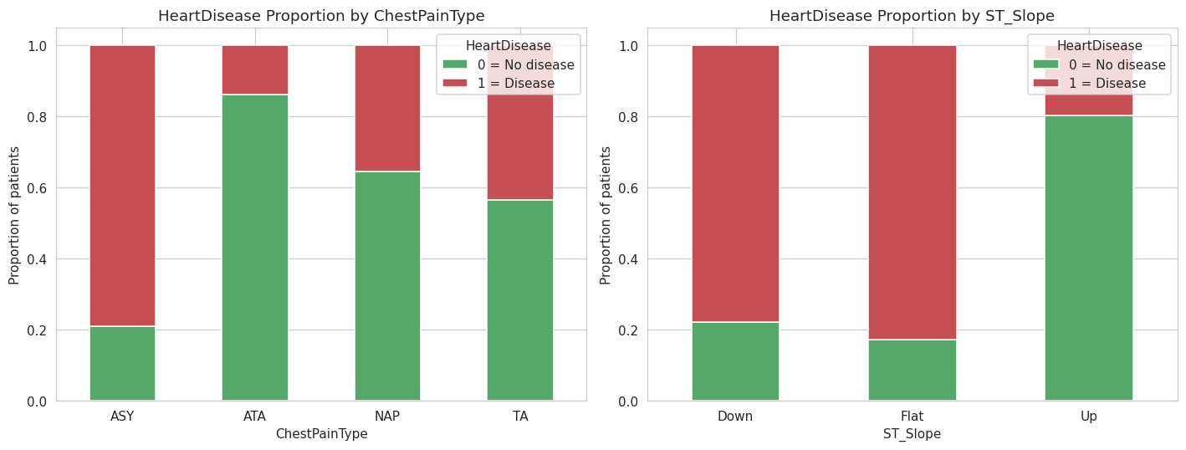
Figure 1. Heart disease proportion by chest pain type and ST slope category.

3. Combining risk factors reveals a compounding effect
A multivariate pivot of ExerciseAngina against ST_Slope showed that patients with both exercise-induced angina and a Flat/Down ST slope carry substantially higher disease rates than either factor alone. This compounding pattern was captured in a new engineered feature, ClinicalRiskScore (a count of four key risk flags), which showed the strongest relationship with the target of any feature in the dataset, disease rate rose from 5.7% at a score of 0 to 100% at a score of 4.
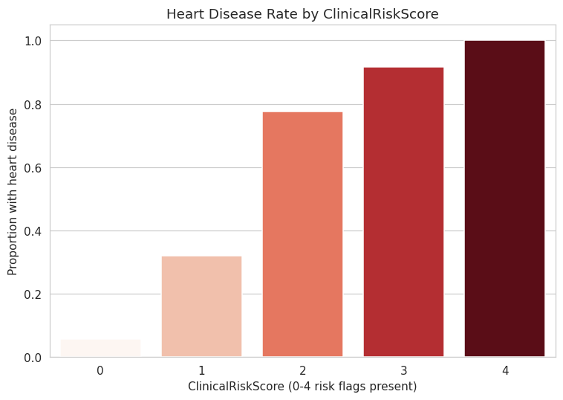
Figure 2. Heart disease rate by ClinicalRiskScore (0-4 risk flags present).

4. Clinical risk bands add interpretable, non-linear signal
Binning Cholesterol and RestingBP into standard clinical risk bands revealed threshold effects: disease rate roughly doubles once cholesterol crosses 240 mg/dl (High band, 67.7% disease rate vs. 39-41% below it), and rises steadily across blood pressure stages, reaching 68.2% at Stage 2 hypertension (≥140 mmHg).

5. No original clinical feature was found redundant
A combined correlation, mutual information, and Random Forest importance analysis found no pair of original clinical features exceeding a 0.75 correlation threshold. Only two Week 2 engineered features (AgeGroup and HR_Reserve) were removed after evidence confirmed they mechanically duplicated existing continuous features (Age and MaxHR respectively).
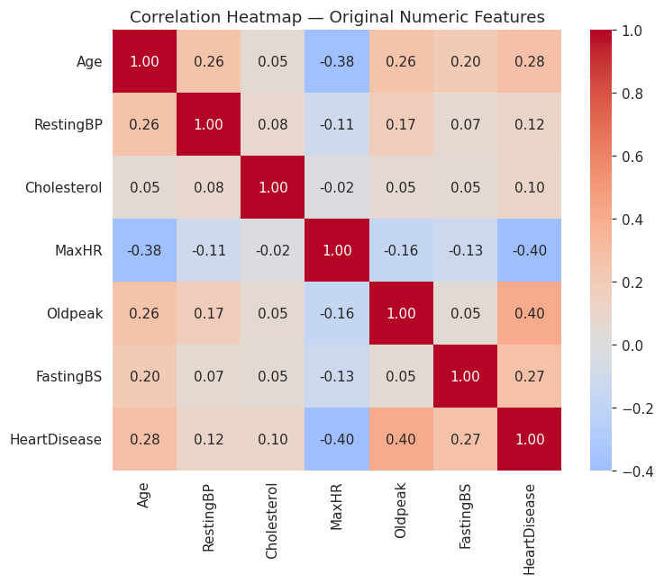
Figure 3. Correlation heatmap of original numeric clinical features.

Business Implications
- A short list of low-cost, routinely collected measurements (chest pain type, exercise angina, ST slope, cholesterol, and maximum heart rate) carries most of the statistically validated risk signal, a screening approach does not need expensive or invasive testing to be effective.
- Asymptomatic patients should not be treated as lower priority by default; the data shows the opposite is often true for this population.
- A simple, explainable "risk flag count" communicates compounding risk to clinicians and patients far more intuitively than any single lab value, and its predictive strength here suggests it is worth prototyping as a first-pass clinical screening tool ahead of a full model.
- Age-adjusted thresholds are advisable for heart-rate-based screening, since maximum heart rate naturally declines with age independent of disease status.

Recommendations
- Prioritise ClinicalRiskScore, ST_Slope, Cholesterol, MaxHR, ChestPainType, and Oldpeak as core features for the Week 4 predictive model, they show the strongest statistical and model-based signal identified so far.
- Retain both Oldpeak and its log-transformed version (Oldpeak_Log) into Week 4, and let model selection determine which serves each candidate algorithm best (raw for tree-based models, log-transformed for linear/logistic regression).
- Consider piloting a simplified clinical risk-flag checklist (mirroring ClinicalRiskScore) as an interim, low-tech screening aid in clinics while the full predictive model is developed and validated.
- Communicate the asymptomatic chest pain finding to partner clinicians directly, since it runs counter to an intuitive (but here inaccurate) assumption about pain severity and risk.

Dataset Limitations
- Sample size: 918 patients, combined from five historical studies (Cleveland, Hungarian, Switzerland, Long Beach VA, Statlog) collected at different times and sites, which may introduce unmeasured site-level variation.
- Missing data: 18.7% of Cholesterol values were disguised as zeros and required imputation; although imputed by diagnosis group, this remains an estimate rather than an observed value for those patients.
- Generalisation: the dataset may not reflect the demographic or clinical profile of the patient populations AnalystLab Africa's clients serve, and any model trained on it should be locally validated before deployment.
- Cross-sectional design: all measurements are taken at a single diagnostic encounter, so the dataset cannot speak to how risk evolves over time for an individual patient.

Next Steps for Week 4
The refined dataset (heart_week3_final_modelling_dataset.csv: 918 rows, 16 columns, encoding-and-scaling-ready) provides a validated, well-documented foundation for Week 4 Machine Learning Model Development. Priority features for initial model iterations are ClinicalRiskScore, ST_Slope, Cholesterol, MaxHR, ChestPainType, Oldpeak (and Oldpeak_Log), consistent with the statistical and feature-importance evidence gathered this week. Model evaluation should include a fairness/robustness check across Sex and Age groups, given the dataset's imbalance toward male patients (725 of 918, 79%).

